**Module 1_ AWS_Fundamentals_Cloud**

================================================================

Submitted to Vikul_Sir

Submitted by Nalathati Rahul

Submission Date –03/Feb/2026

==================================================================================

L4 - Connect to the AWS EC2 Ubuntu Instance and Update default packages, install JDK, Maven, Git, and validate the versions

Step:1 login into AWS console

Step: 2 open EC2 instance

🡪Name the instance: my-ec2-instance

🡪Select the OS(AMI): Amazon Linux

🡪create key pair

🡪check network configures and configures storage

🡪Click launch instance

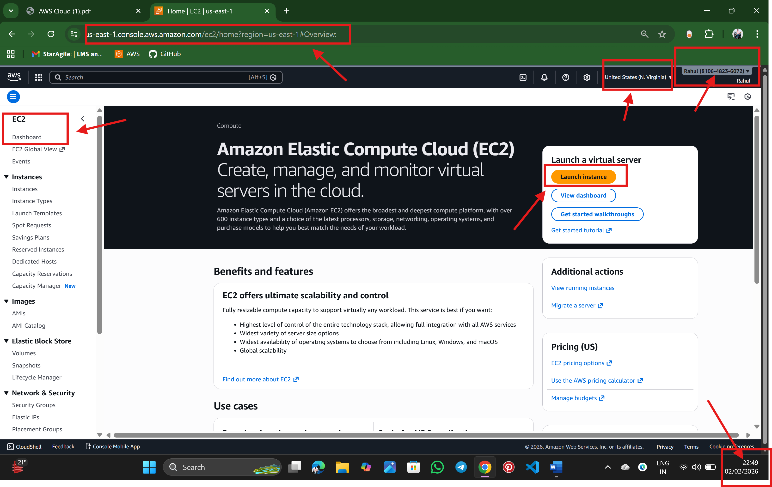

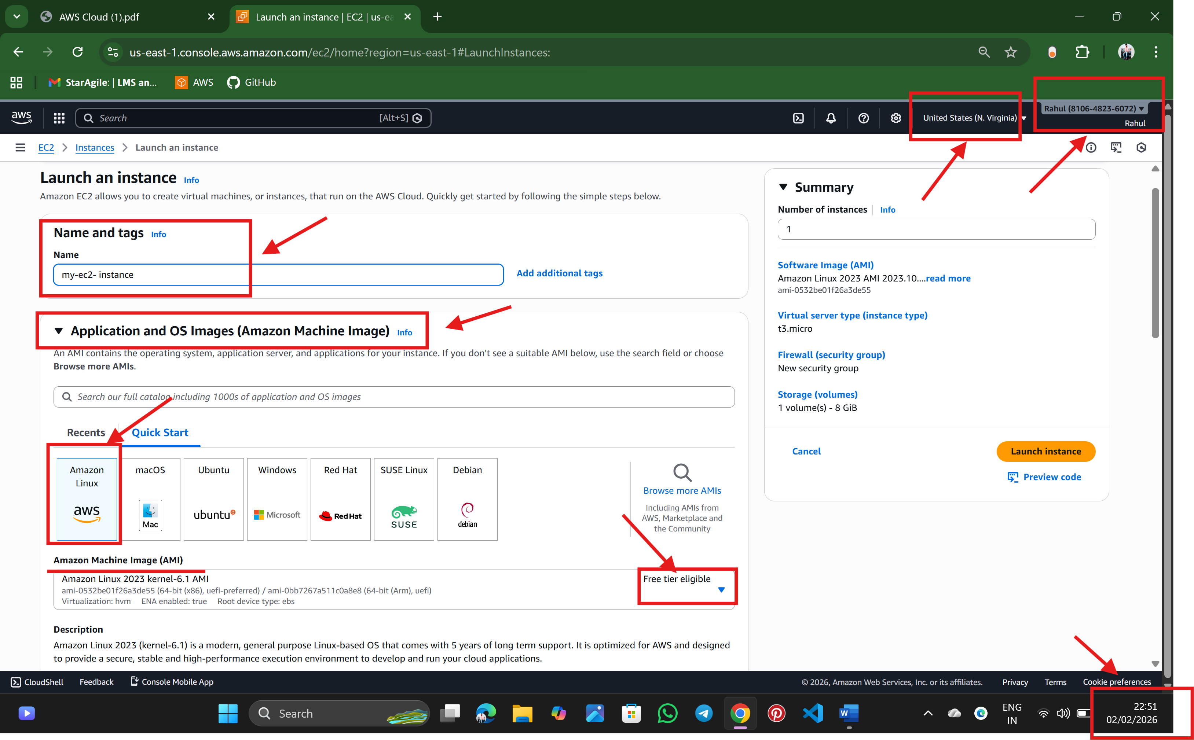

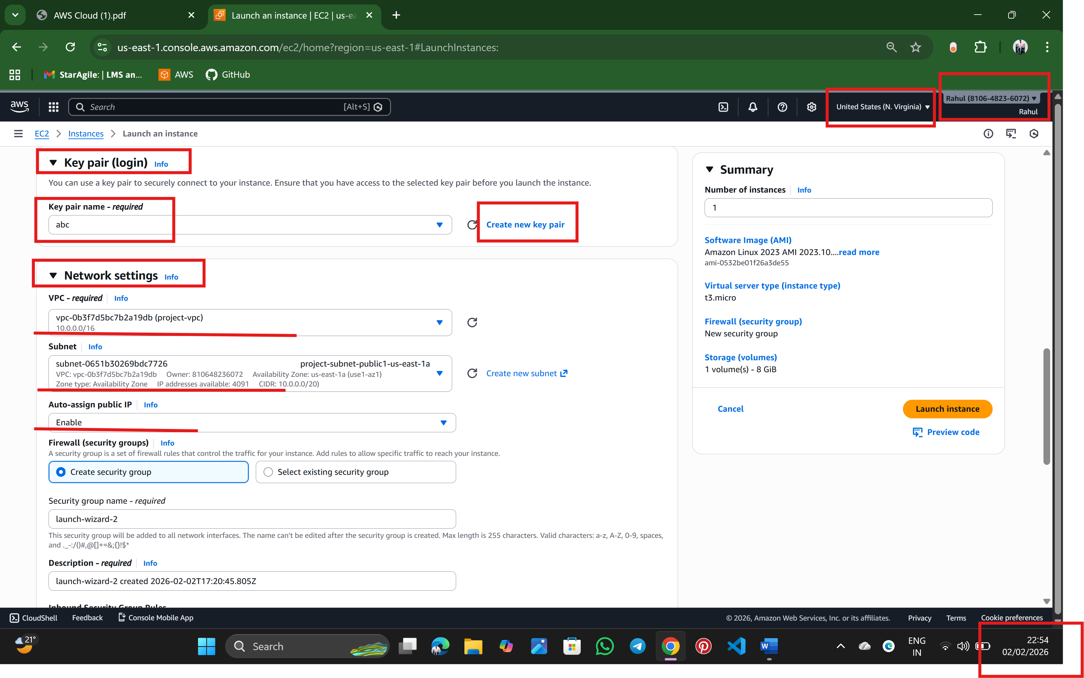

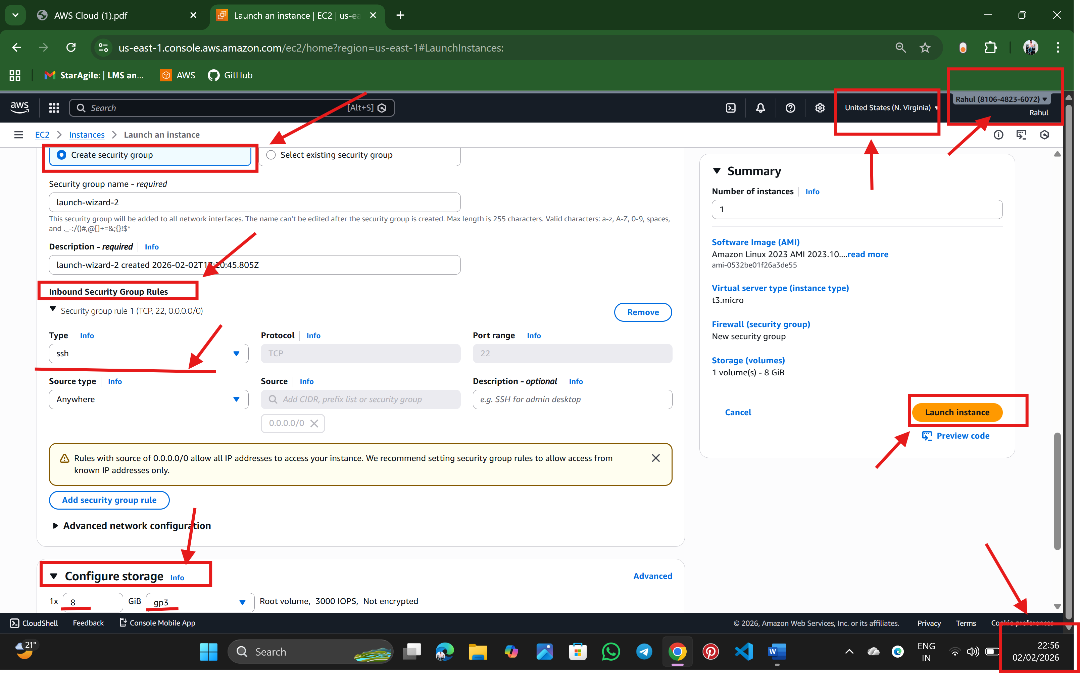

Step:3 The instance is successfully launch

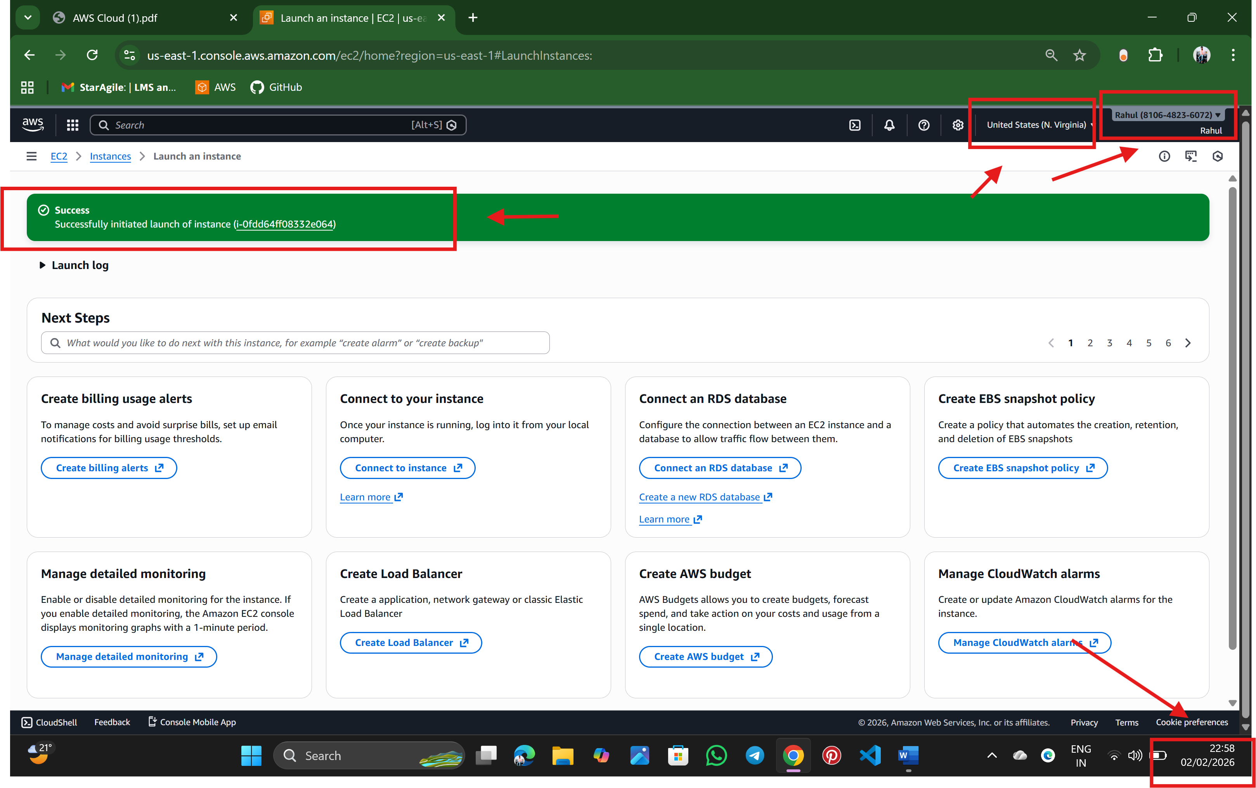

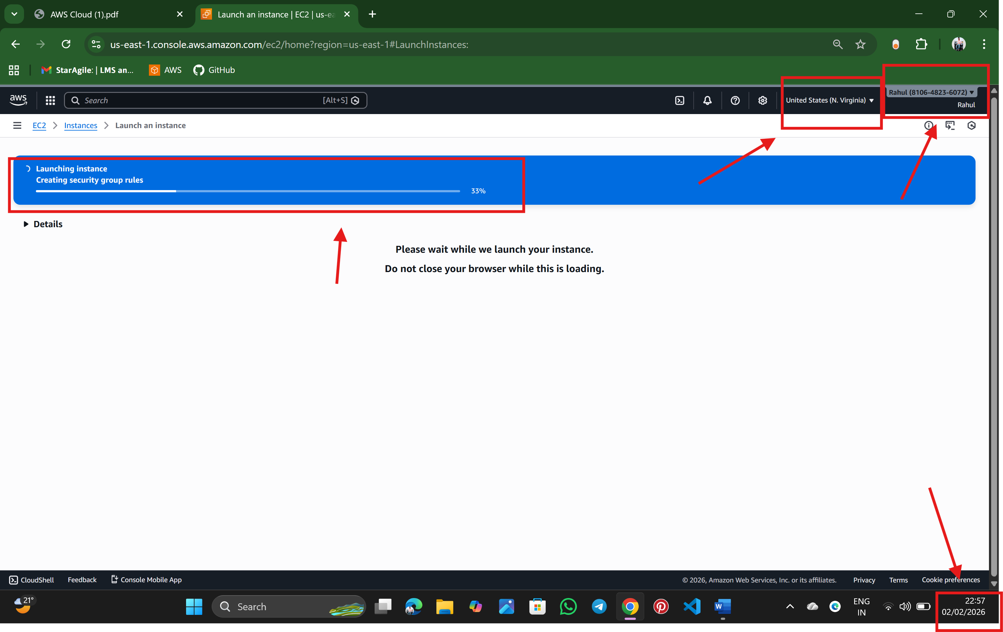

Step:4 Now, connect the instance

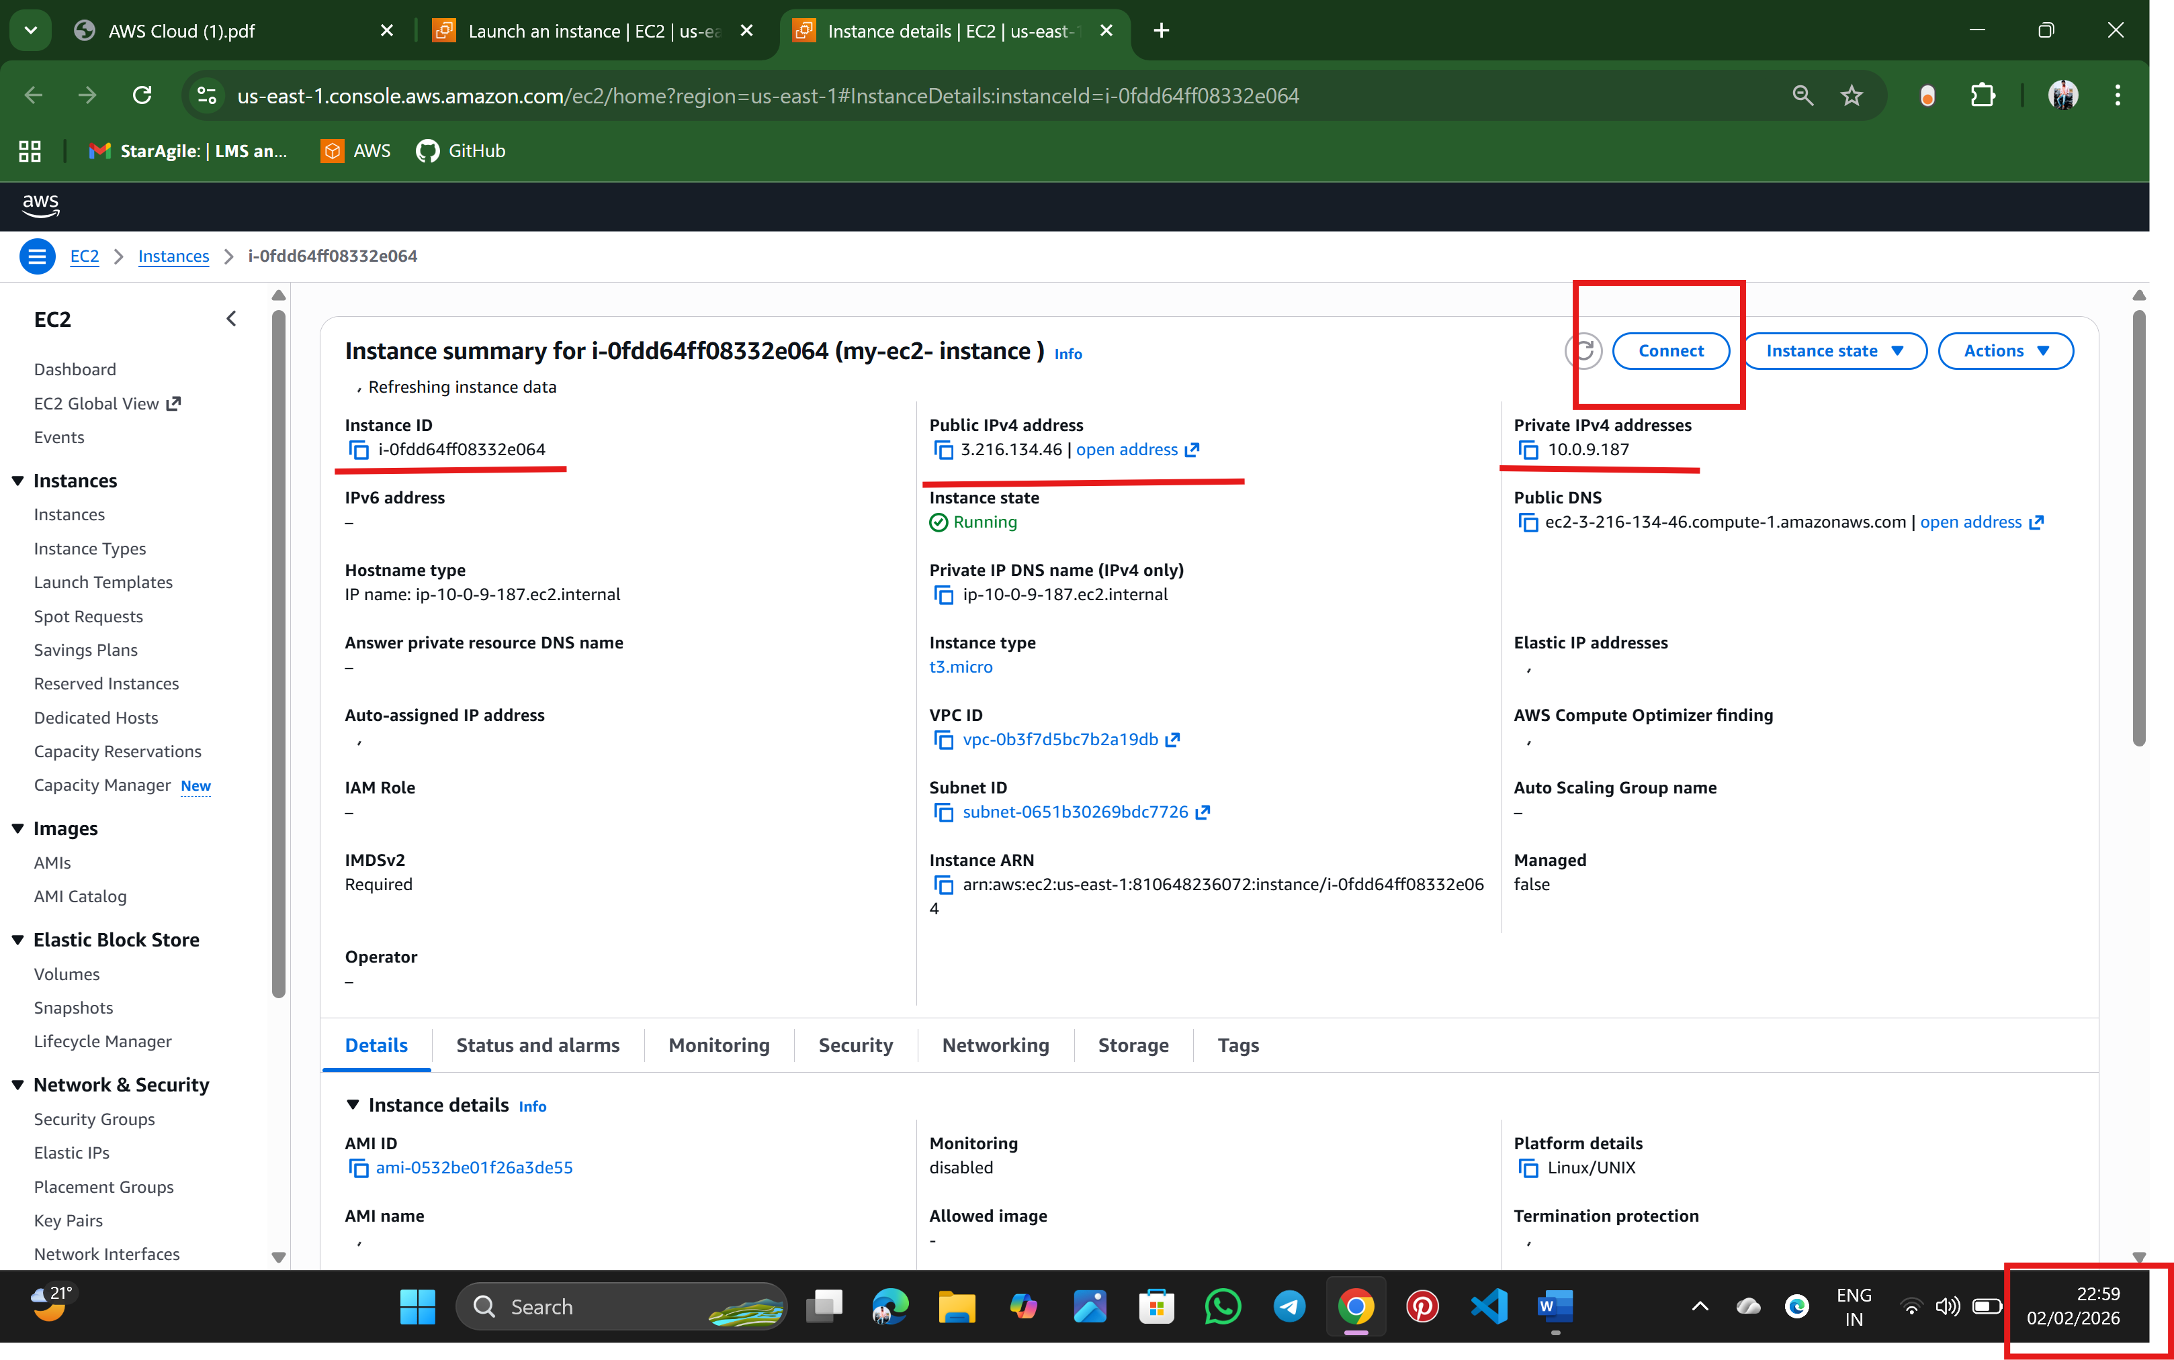

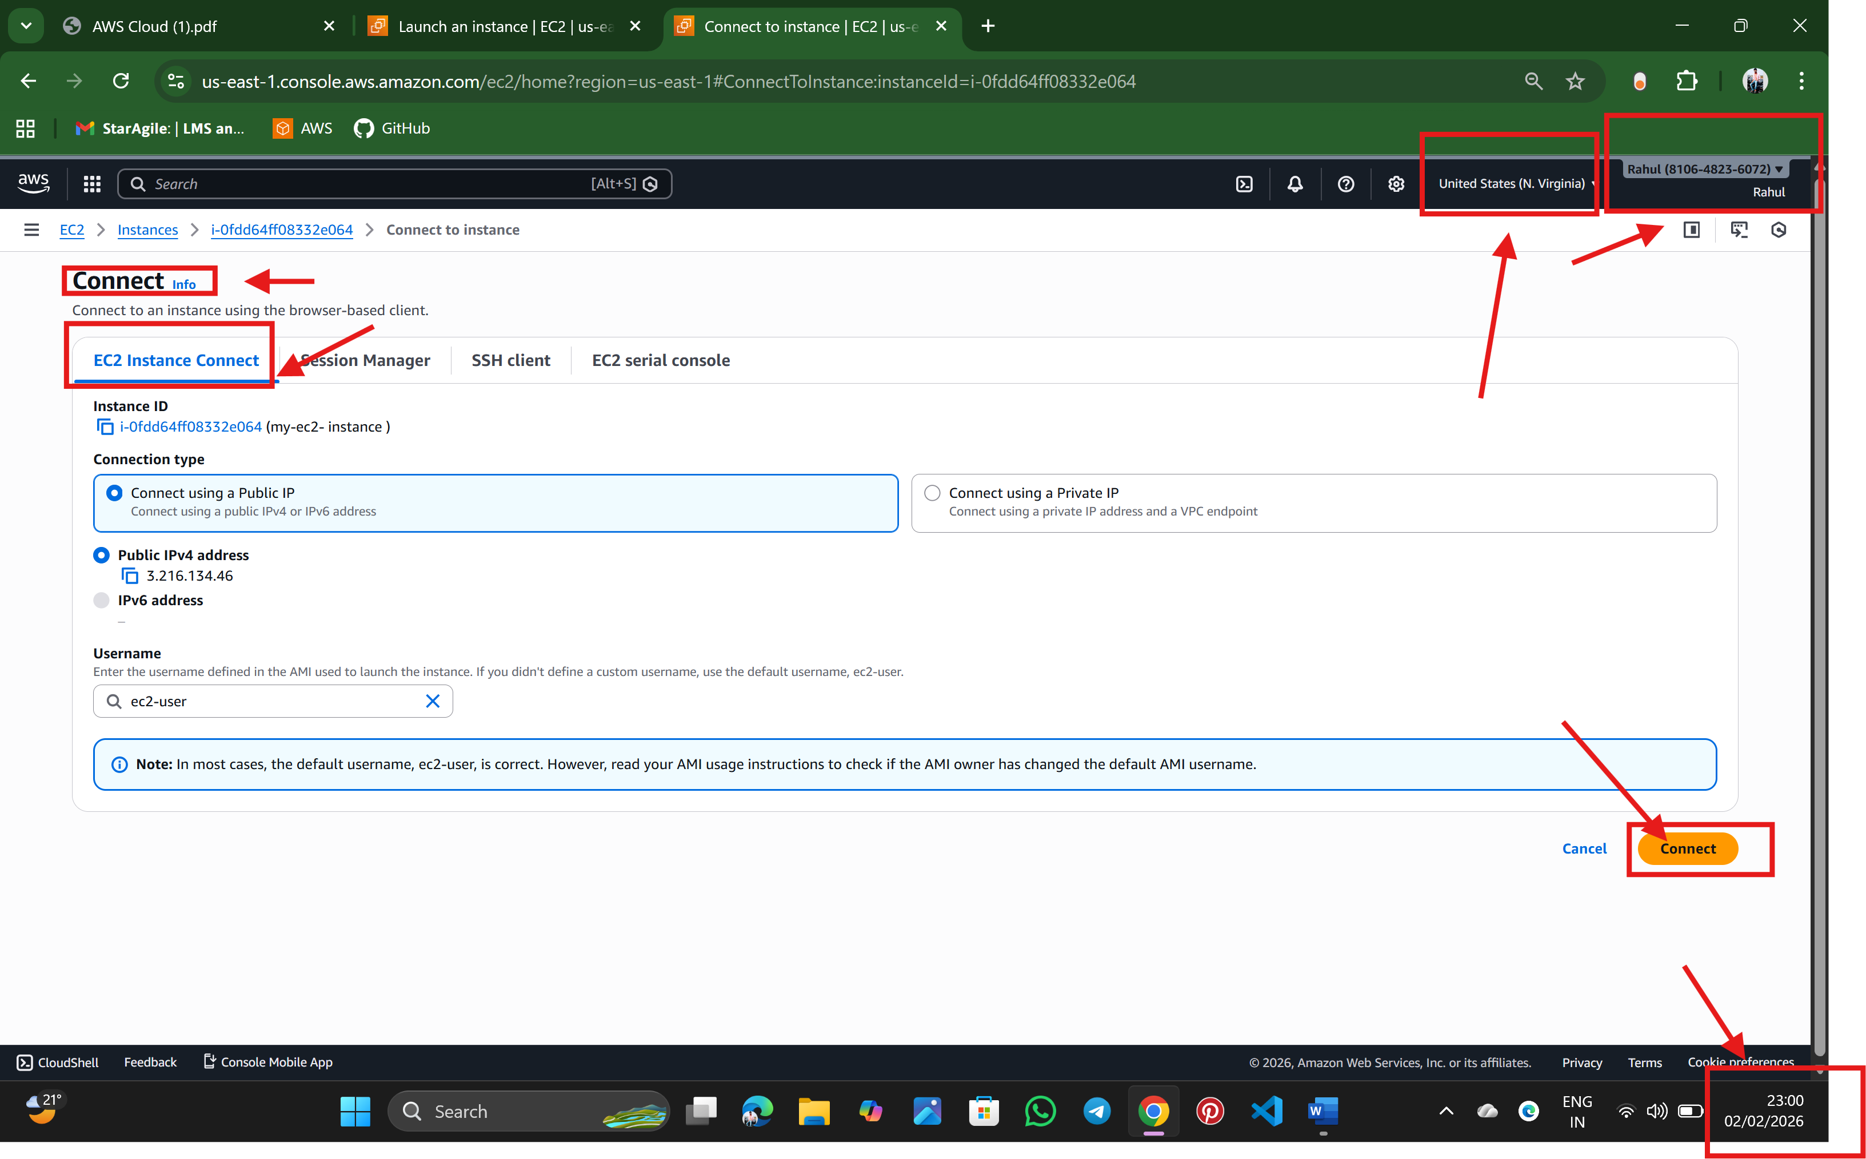

Step:5 The Ubantu terminal is launch

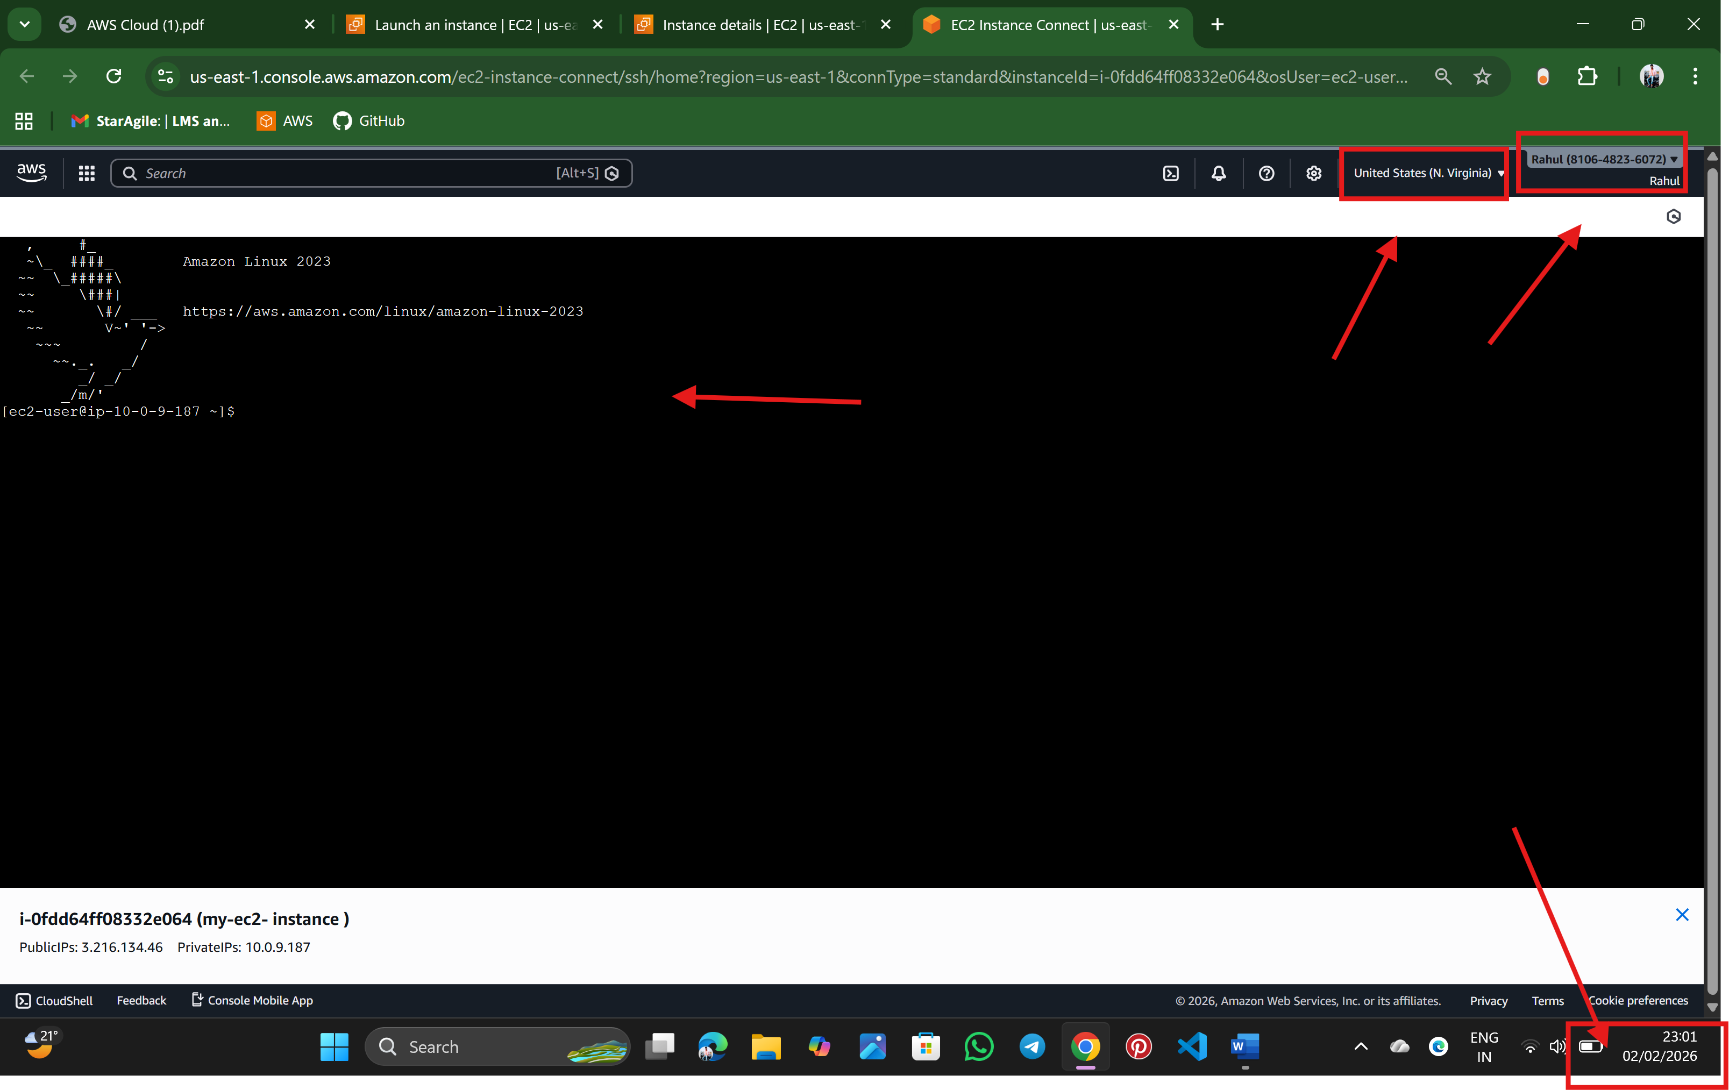

Step: 6 Update Default Packages

Sudo yum update

sudo yum upgrade -y

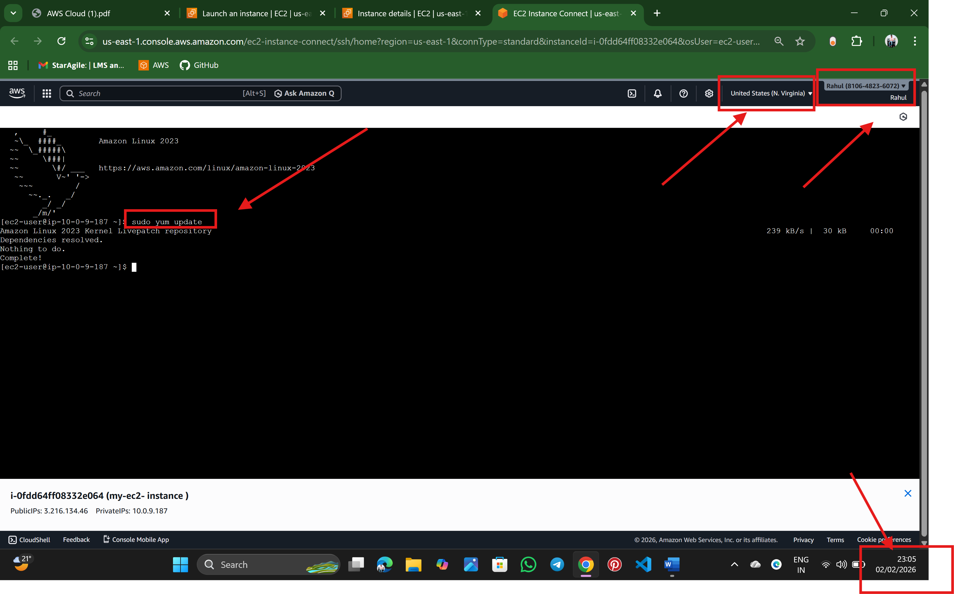

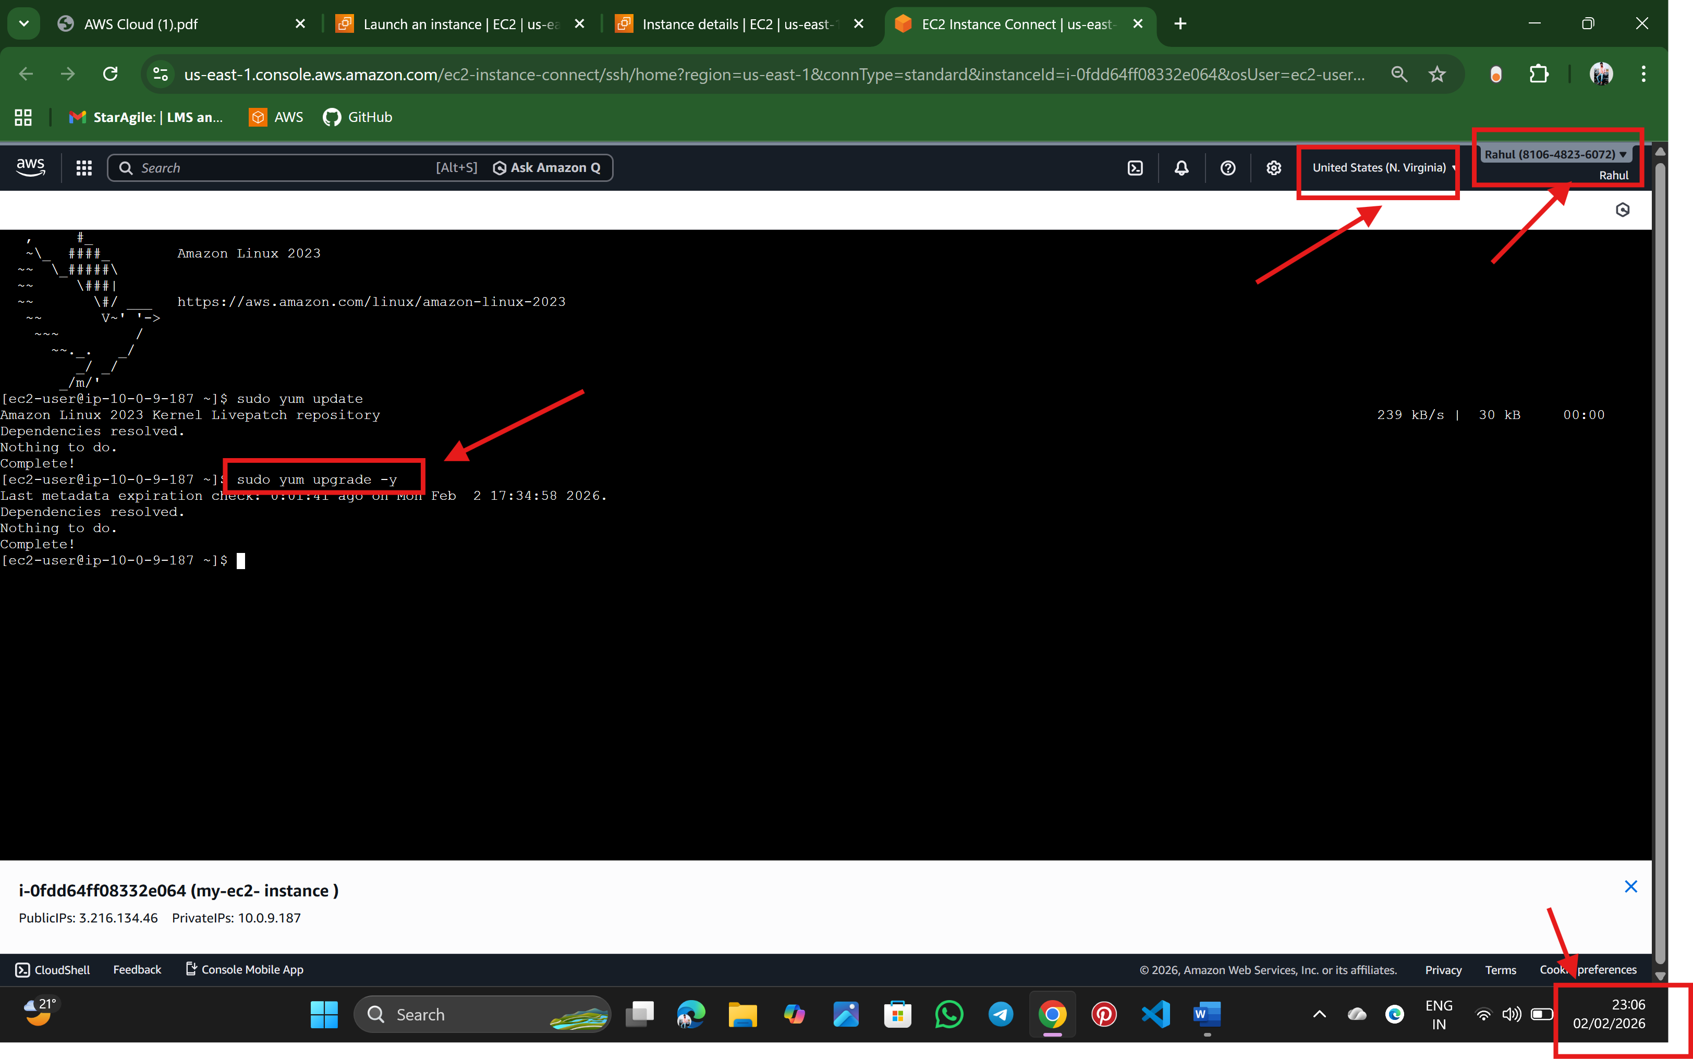

**Step: 7 Install JDK (Java)**

sudo yum install java

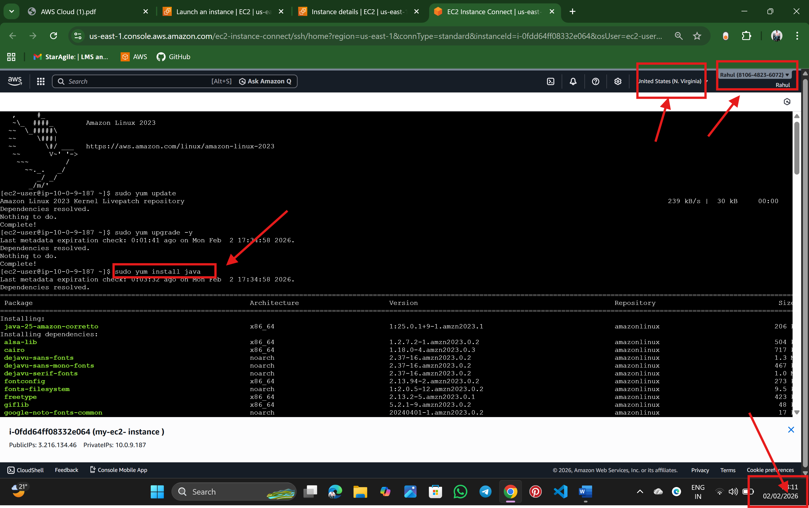

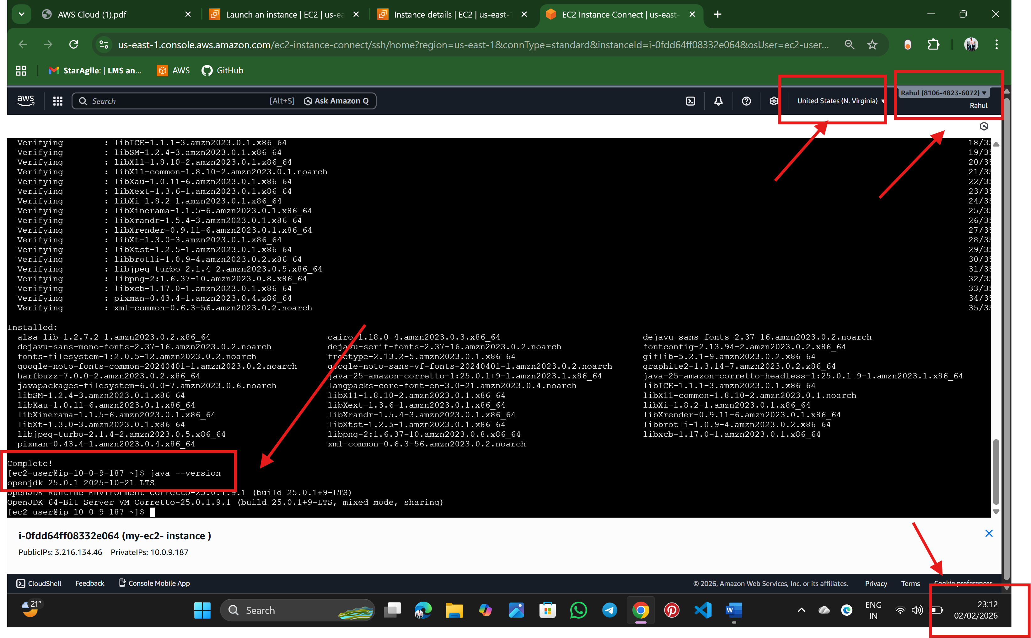

**Step: 8 Install Maven**

sudo yum install maven -y

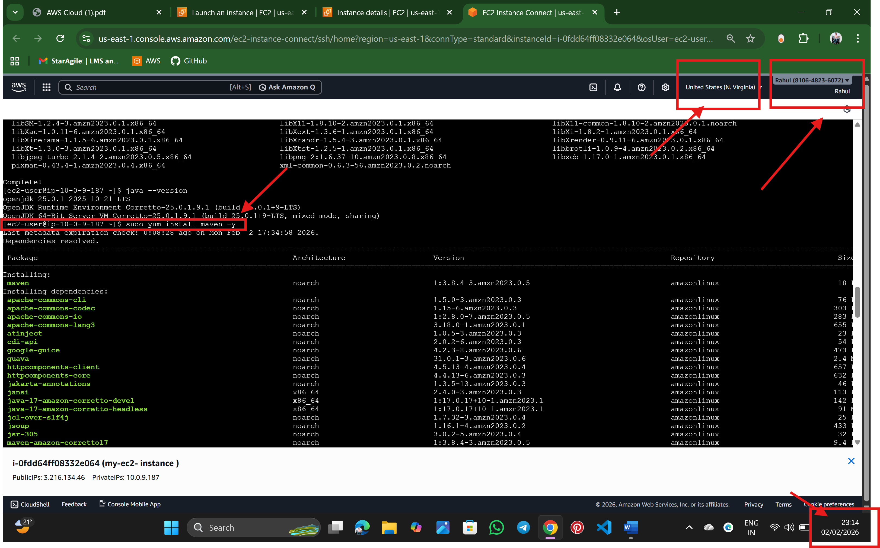

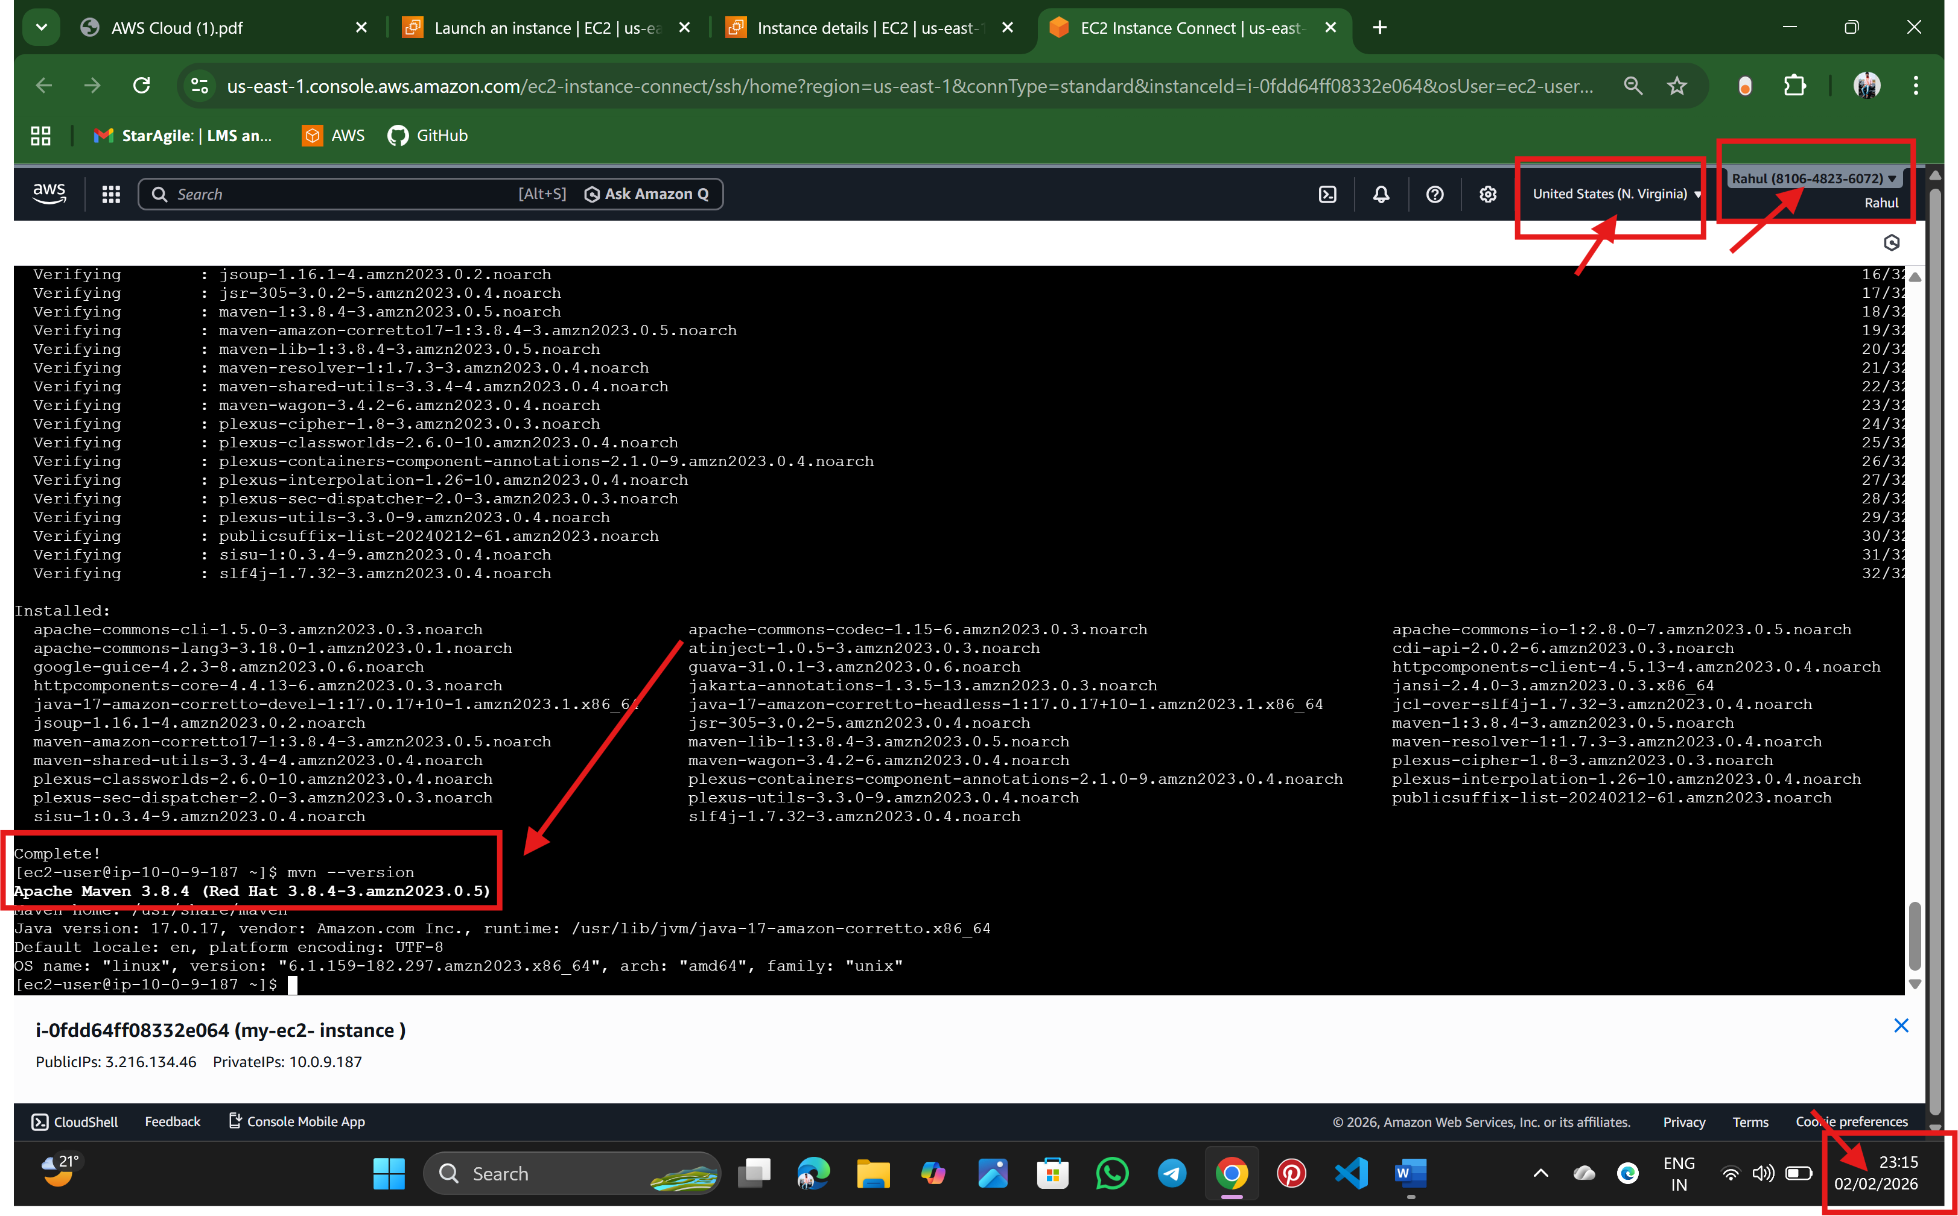

**Step: 9 Install Git**

sudo yum install git -y

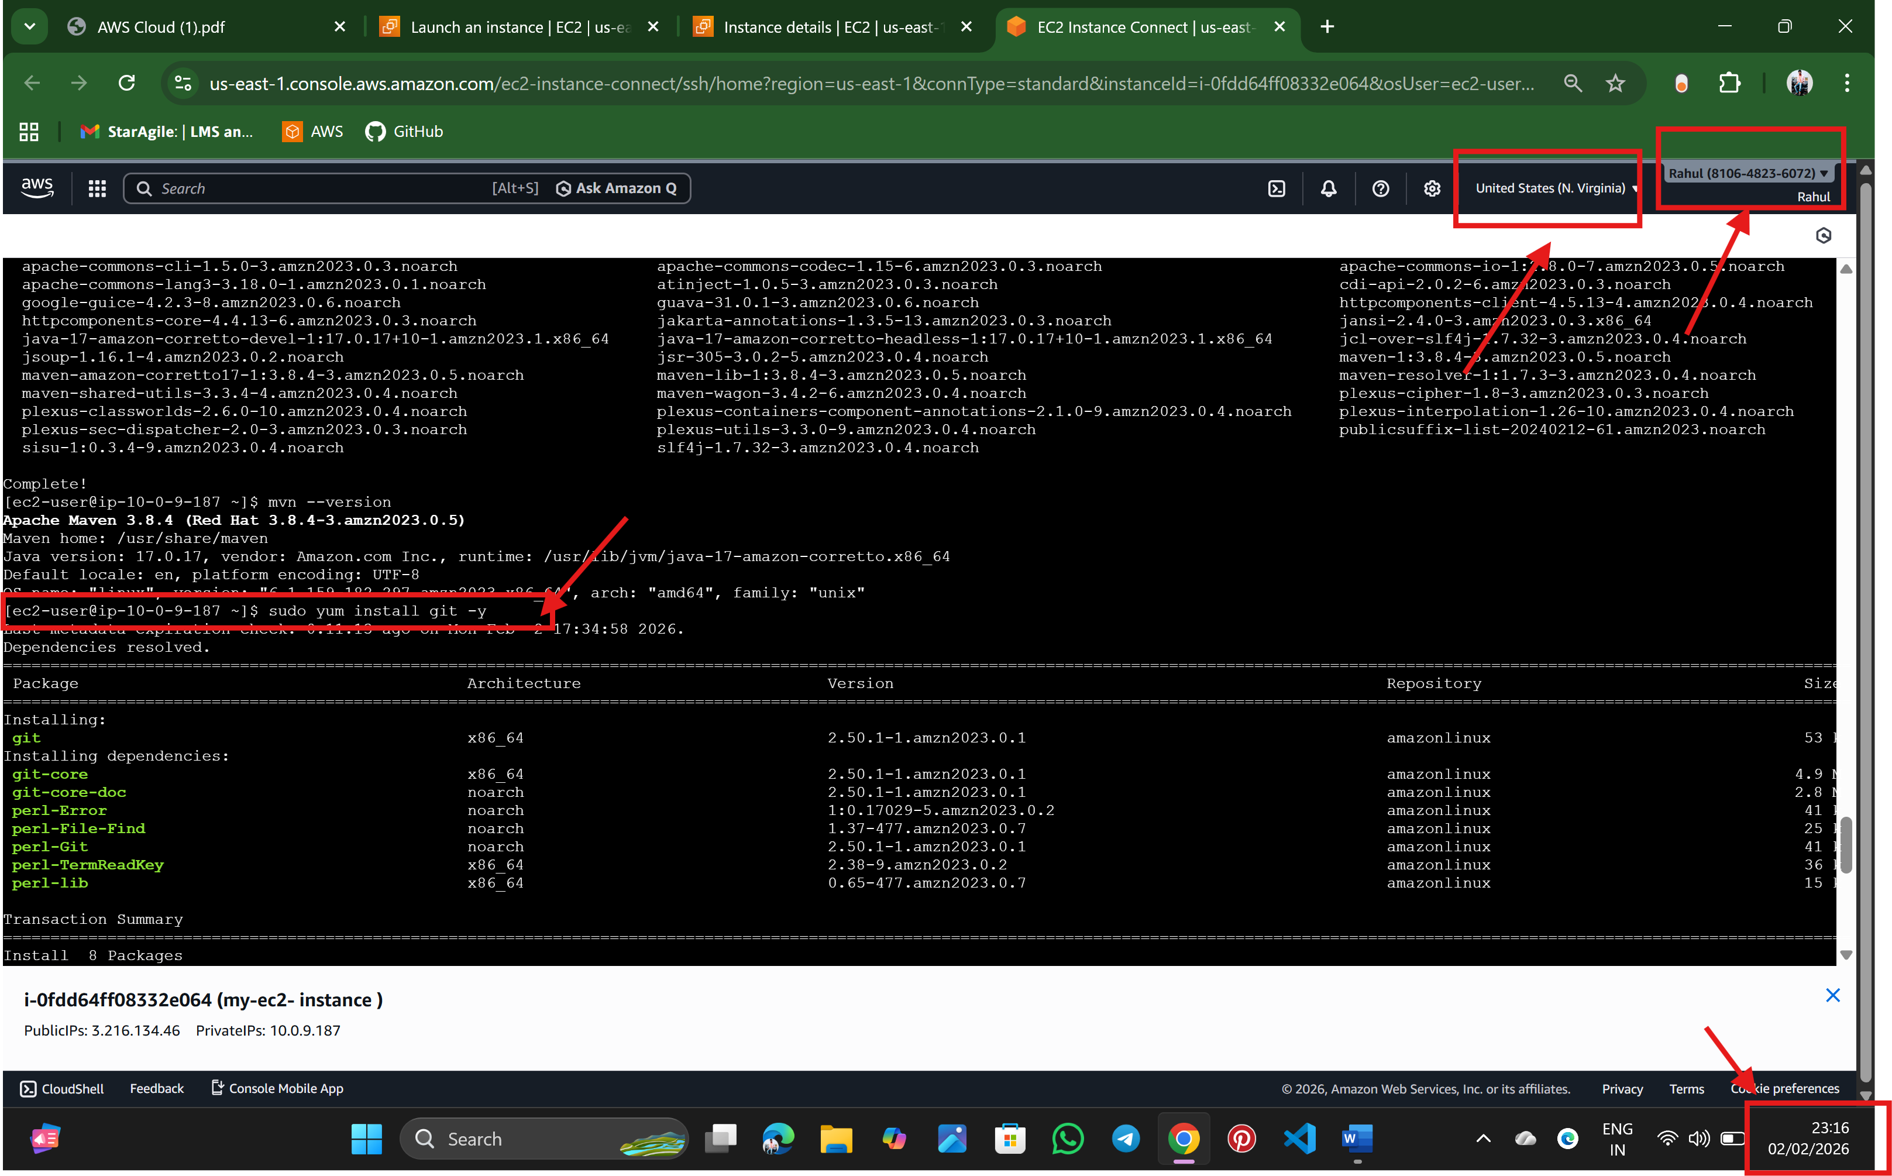

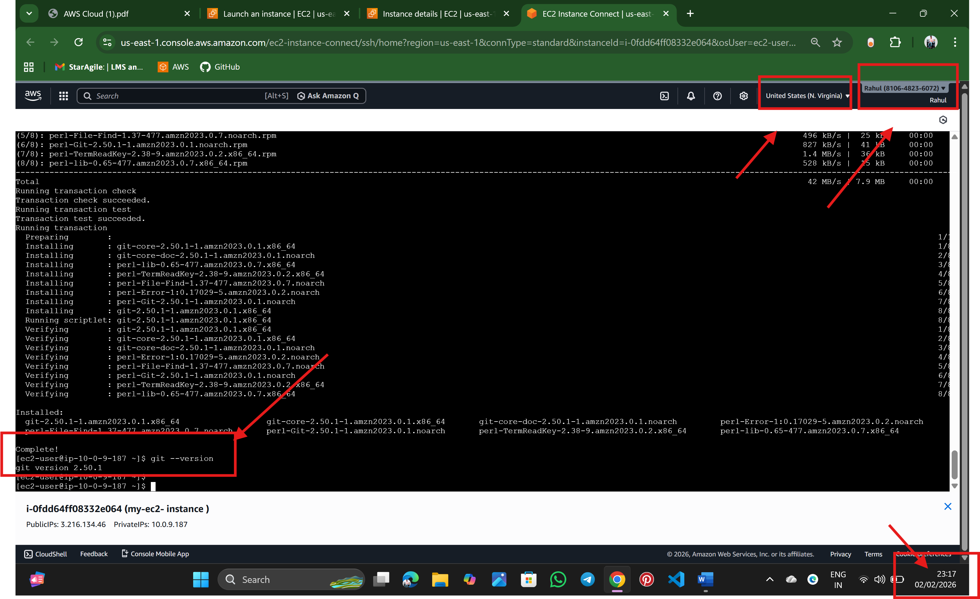

Step: 10 finally validate the versions of java, maven, and git

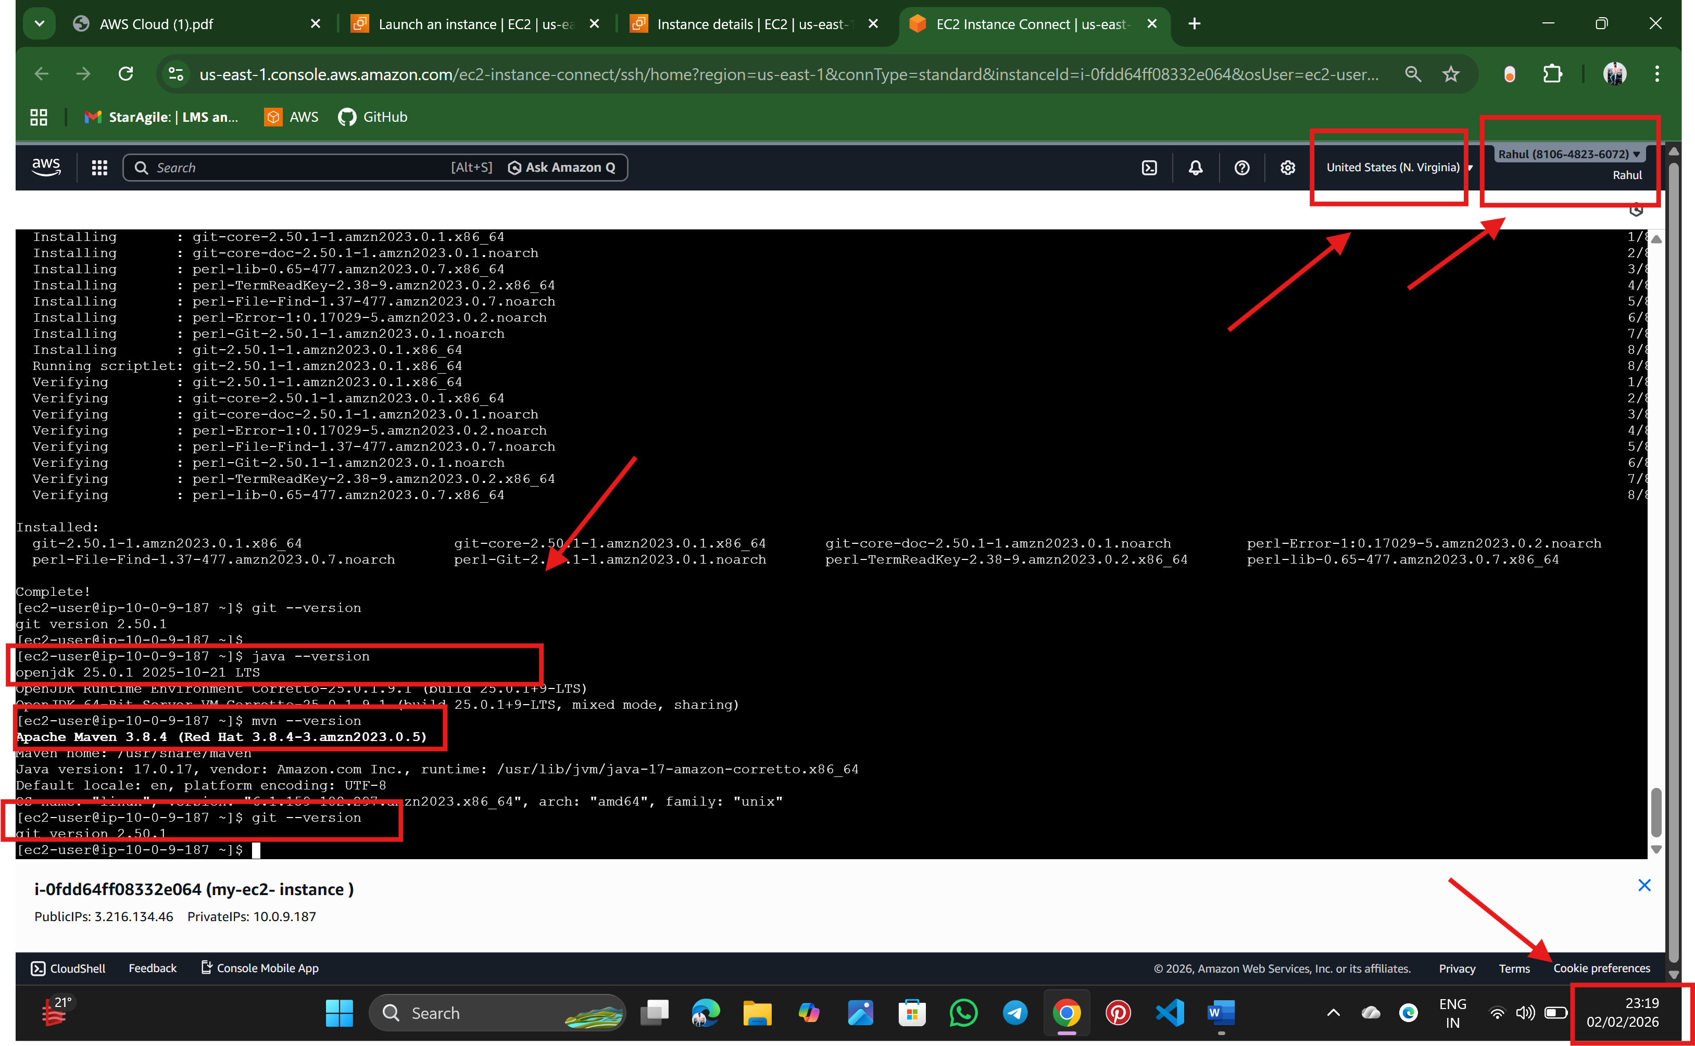

🡪Rahul Nalathati